1. Daily notes

Array – Array is an object, which stores a group of elements of the same data type.

It is a data structure where we can store similar elements.

Size array is fixed hence cannot grow or shrink.

**Multi dimensional Array** – Data stored in rows and columns

1. Interview questions
2. Difference
3. Program using single dimensional array
4. Write a program to add two matrices.
5. 1) [**Java program to print number of elements in an array**](https://beginnersbook.com/2022/06/java-program-to-print-number-of-elements-in-an-array/)

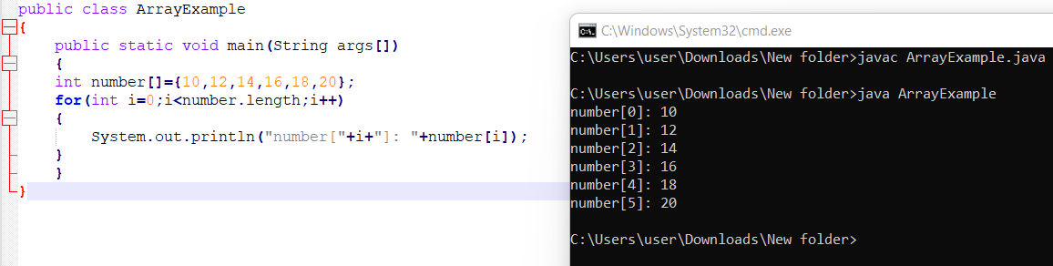  
2) [**Java program to remove duplicate elements in an array**](https://beginnersbook.com/2022/06/java-program-to-remove-duplicate-elements-in-an-array/)  
3) [**Java program to find smallest number in an array**](https://beginnersbook.com/2022/06/java-program-to-find-smallest-number-in-an-array/)

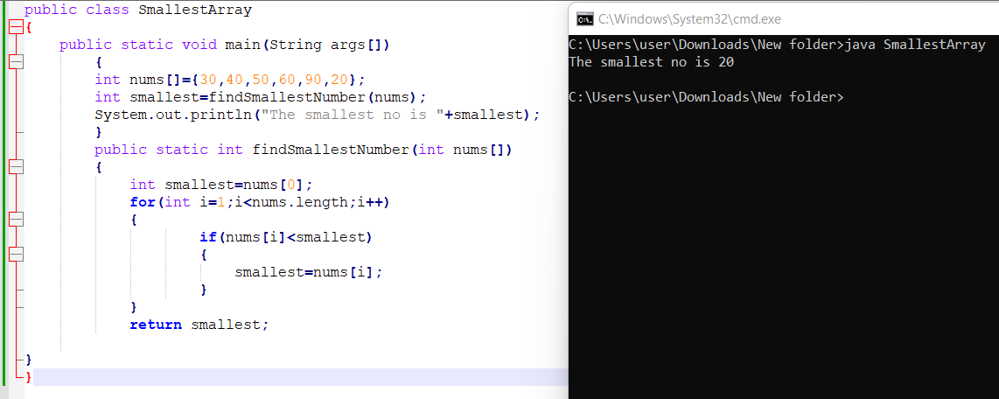  
4) [**Java program to find largest element of an array**](https://beginnersbook.com/2022/06/java-program-to-find-largest-element-of-an-array/)

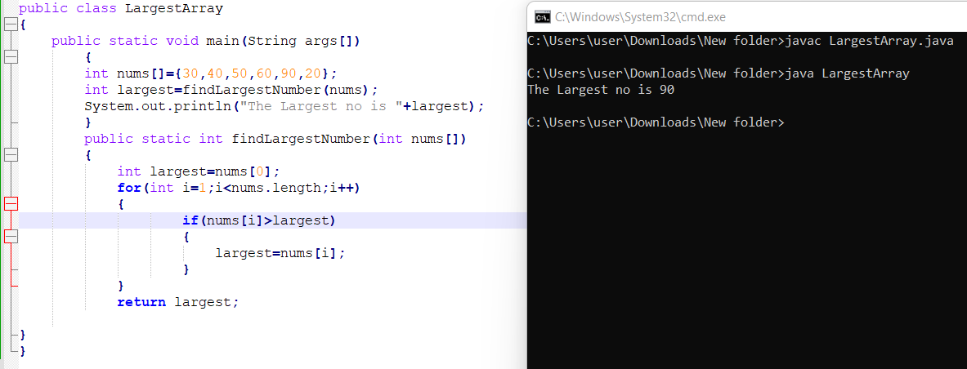  
5) [**Java program to print the duplicate elements of an array**](https://beginnersbook.com/2022/06/java-program-to-print-the-duplicate-elements-of-an-array/)

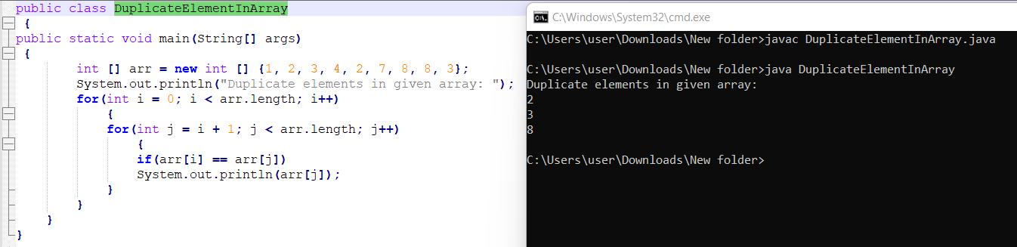  
6) [**Java program to copy all elements from one array to another array**](https://beginnersbook.com/2022/06/java-program-to-copy-all-elements-of-one-array-into-another-array/)

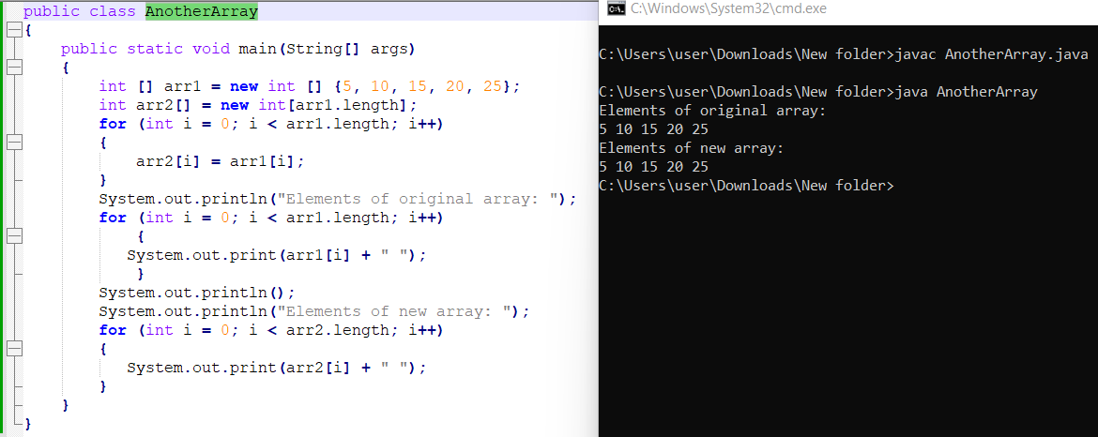  
7) [**Java program to print the elements of an array present on even position**](https://beginnersbook.com/2022/06/java-program-to-print-the-elements-of-an-array-present-on-even-position/)

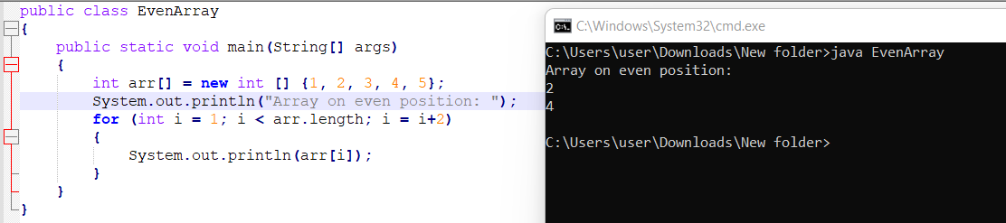  
8) [**Java program to add two matrix using multidimensional arrays**](https://beginnersbook.com/2019/12/java-program-to-add-two-matrix-using-multi-dimensional-arrays/)

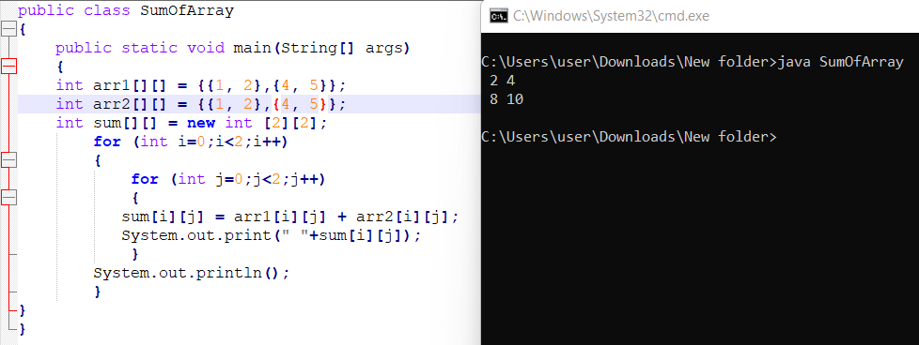  
9) [**Java program to check whether two matrices are equal**](https://beginnersbook.com/2022/02/java-program-to-check-whether-two-matrices-are-equal/)

10) **Write a program to sum up all the elements of an array.**

